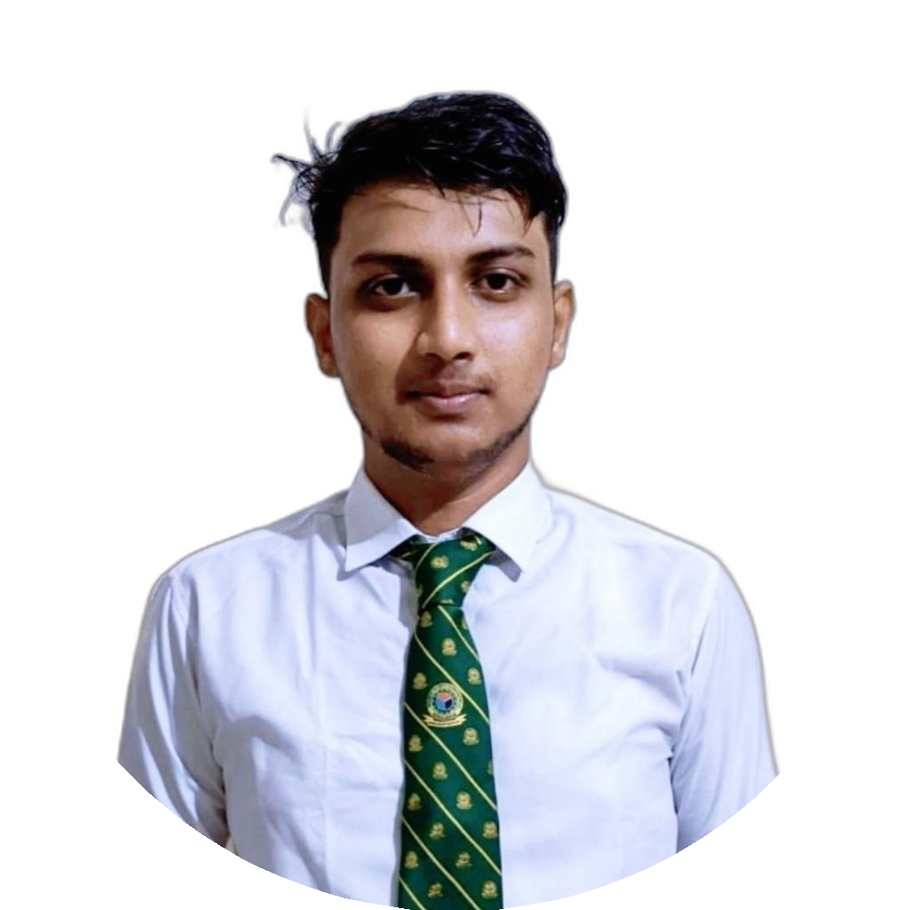

MD. MARUF MULLAH
Mobile: +8801609099183
Email: md.marufmullah50@gmail.com LinkedIn: linkedin.com/in/marufmullah50 Dhaka, Bangladesh
EDUCATION

BSc Mechanical Engineering
MIST, Dhaka
May 2021 - May 2025 CGPA: 3.23/4.00

HSC
Abdul Kadir Mollah City College GPA: 5.00/5.00
SSC
Siraj Nagor M.A. Pilot High School GPA: 5.00/5.00

SKILLS

Programming: Python, C, HTML

Machine Learning & Data Analysis:
TensorFlow, PyTorch, Scikit-learn, NumPy, Pandas, Matplotlib, Seaborn

Engineering Tools: SolidWorks,,AutoCAD ANSYS, MATLAB, CAD/CAM, 3D Printing
Documentation: LaTeX, MS Office, Google Workspace
Soft Skills: Team Collaboration, Communication, Problem-Solving, Time Management

MD. MARUF MULLAH

CAREER OBJECTIVES

Motivated Mechanical Engineering graduate with a solid foundation in fluid mechanics, HVAC systems, and materials engineering. I aim to contribute to practical, real-world solutions through design, analysis, and system optimization. Alongside my core skills, I've explored Machine Learning and Artificial Intelligence to bring modern, data-driven insights into engineering tasks, making my approach both innovative and adaptable to evolving industry needs.

EXPERIENCE

IFAD Autos Ltd. - Industrial Attachment, Dhamrai
Completed internship covering vehicle assembly, mechanical fitting, and quality control processes.

KAPL, PRAN GROUP – 7-day Assessment, Gazipur
Completed 7-day assessment covering flour, feed, pulses, printing, and packaging operations, including process mapping, critical control point identification, and productivity improvement recommendations.

CERTIFICATIONS

Machine Learning Specialization – Coursera

Neural Networks and Deep Learning – Coursera Project-Based Excel – Grameenphone Academy Google Sheets – Simpli Learn
Python Programming Bootcamp -Decoders Academy

PROJECTS

Tailstock Tool Holder Design: Designed and manufactured an ergonomic tailstock die tool holder using SolidWorks and lathe machining.
Smart Bluetooth Vacuum Car: Built an Arduino-controlled CPU-fan cleaning car with Bluetooth remote control.

EXTRA-CURRICULAR ACTIVITIES

Sports volunteer and scout Volunteer at ICMEAS 2022, MIST
Volunteer at MIST Job Fair 2022

REFERENCES

Major Md. Anisur Rahman, EME Assistant Professor, ME Dept., MIST anisur@me.mist.ac.bd
Dr. Md Sayem Hossain Bhuiyan, Associate Professor, ME Dept., MIST sayem@me.mist.ac.bd

